Soil Biol. Biochem. Vol. 20, No. 6, pp. 891-.897, 1988 0038-0717/88 $3.00 + 0.00Printed in Great Britain Pergamon Press plc

UREIDE PRODUCTION BY N₂-FIXING AND
NON-N₂-FIXING LEGUMINOUS TREES

C. VAN KESSEL¹, J. P. ROSKOSKI² and K. KEANE²
¹University of Saskatchewan, Department of Soil Science, Saskatoon, Canada S7N OWO and ²NifTAL Project, Department of Agronomy and Soil Science, University of Hawaii, 1000 Holomua Avenue, Paia, Hawaii 96779, U.S.A.

(Accepted 5 March 1988)

Summary-Xylem-sap and stem and leaf extracts from 35 species, comprising 14 genera, of leguminous trees were analyzed for ureides, nitrate and a-amino acids. Trees were either inoculated with Rhizobium or fertilized with NH₄NO₃. The dominant form of soluble N in stem and leaf extracts and xylem sap was a -amino acids. Certain non-N₂-fixing species, i.e. Tamarindus indica and Adenanthera pavonina, produced significant amounts of ureides. Several N₂ fixing species, Mimosa scabrella, Sesbania grandflora, Acacia mearnsii and Gliricida sepium, grown on mineral-N had higher absolute amounts of ureides in both extracts and exudates than did most nodulated species. Nodulated A. mearnsii and S. grandiora, had the highest amounts of ureides in xylem sap. The relative abundance of ureides in stem and leaf extracts was lower than in xylem sap, but was correlated. Results indicated that the presence of ureides, per se, was not a reliable indicator of N₂-fixing activity. Moreover, the relative abundance of ureides in most of the species tested was too low to use as a presumptive test for, or as a means of, estimating N₂ fixation.
INTRODUCTION
Leguminous trees occur worldwide and are particularly abundant in tropical ecosystems (Knight, 1975). Many species grow rapidly and have been traditionally used for fuelwood, forage for animals, erosion control or soil enrichment (Roskoski et al., 1980). This multi-use potential has recently led to their widespread promotion by international agencies for reforestation and other development projects (National Academy of Science, 1977, 1979, 1980). The soil enrichment potential of these species has usually been attributed to their ability to fix N₂. However, little quantitative data on N₂ fixation in tree legumes in situ exists largely because of methodological problems.
It is often difficult to collect nodules due to soil conditions or rooting patterns of the species under investigation (Rundel et al., 1982). If nodule sampling is possible, numerous samples have to be taken many times throughout the year before a reliable estimate of nodule biomass and N₂-fixing activity can be obtained using the acetylene reduction method (Roskoski, 1981; Hansen and Atkins, 1987a). The ¹⁵N dilution method is usually precluded because of the size of the area that must be labeled and the methodological difficulties of incorporating the label throughout the rooting zone of the tree. The ¹⁵N natural abundance method for measuring N₂ fixation in situ appears promising (Shearer et al., 1983; Shearer and Kohl, 1986) but still requires costly analyses and is likely to be unsuitable in ecosystems with marked heterogeneity in ¹⁵N discrimination of soil N (Hansen and Pate, 1987).
Some herbaceous legumes produce large quantities of ureides, a group of N compounds including allantoin and allantoic acid, when fixing N but not when dependent on mineral N (Matsumoto et al., 1977). Therefore, the relative abundance of ureides has been
used to detect and quantify N₂ fixation by these species (McClure et al., 1980; Herridge, 1984). Examples of ureide exporters are: soybeans (Glycine max), bean (Phaseolus vulgaris), cowpea (Vigna unguiculata) and mungbean (Vigna radiata) (Atkins, 1982). Other species, such as white clover (Trifolium pratense), alfalfa (Medicago sativa), peanut (Arachis hypogea) and lupins (Lupinus mutabilis) transport fixed N primarily in the form of a-amino acids (Atkins, 1982).
To date, only a few woody legumes have been examined for ureide production (Hansen and Pate, 1987). Since measuring the relative abundance of ureides in presumed N₂-fixing trees could be an easy method for detecting and estimating N₂ fixation in situ, a greenhouse experiment was run in which 35 species of N₂-fixing and non-N₂-fixing leguminous trees were grown with NH₄N0₃ or inoculated with Rhizobium and the abundance of ureides in xylem sap and stems and leaves was determined.

MATERIALS AND METHODS

Seeds of 35 species of leguminous trees (Table 1 were scarified in concentrated H₂SO4 or H202 (Halliday and Nakao, 1984), thoroughly rinsed in sterile water, germinated on water agar plates, and planted in 6.25 l. pots, filled with 750 g coarse gravel at the bottom 4500 ml (mg) vermiculite, and 900 g coarse gravel at the top. At planting, 2 of the 4 pots established for each species were inoculated with a mixture of Rhizobium strains; the other 2 pots remained uninoculated (Table 1). Each pot contained, after thinning, 3 trees. A total of 750 ml of N-free nutrient solution was applied daily to all trees as three separate applications. The N-free nutrient solution consisted of 1 mmol Ca in the form of 0.2 mmol CaCl₂-2H₂0, 0.8 mmol CaSO₄ - 2H₂0,
891
0.5 mmol P as KH₂P0₄, 0.5 mmol K as KHP0₄, and 80,µ11⁻' of micronutrient solution (Monterey Chemical Co.) which contained 1% Mo, 2.5% S, 0.35% B, 0.03% Co, 1.5% Fe, 0.45% Mn, 0.04% Mo, 0.5% Zn and 0.15% Cu. Uninoculated seedlings received 15 mmol N day⁻' in the form of NH₄ N0₃ which was mixed into the N-free nutrient solution that the uninoculated seedlings received.
Initially, 29 species were established and grown for 6 months. Ten additional species were set-up during a second experiment and also grown for 6 months. Four species, Leucanea leucocephala, L. lanceolata, Erythrina sandwicensis and Cassia sturtii were set up in both experiments. A. mearnsii seedlings, solely dependent on N from fixation, were planted during the first experiment but grew so slowly that they were harvested at the end of the second experiment.
At the time of harvest, xylem exudates were collected from stems as described by Herridge (1984). Plants were then removed from the pots, checked for the presence of nodules and separated into roots, stems and leaves. After drying at 70°C to a constant weight, dry wt of leaves and stems were taken. Separate subsamples of leaves and stems were ground in a cyclone mill (< 0.45 mm) and a 0.5 g sample of the dried ground material was boiled for 1.5 min in 20 ml of distilled water. After cooling, the volume was made up to 100ml, centrifuged for 20 min at 10,000 rev min⁻' and the supernatant passed through a Whatman No. 1 filter paper. All extracts, as well as exudates, were frozen until analyzed.
Ureides, allantoin and allantoic acid, were analyzed colorimetrically (Young and Conway, 1942); nitrates were measured by the cadmium reduction method (Keeney and Nelson, 1982); and total aminoacids were determined by the ninhydrin method (Yemm and Cocking, 1955) using asparagine as a standard.

RESULTS AND DISCUSSION

All inoculated trees of N₂-fixing species had nodules at harvest but no NH₄NO₃ fertilized trees of these same species were nodulated. Species reported to be non-N,-fixers (Allen and Allen, 1981), i.e. C. sturth, Delonix regia, Parkinsonia aculeata, T. indica and A. pavonina grown under N-free conditions, did not nodulate with any of the inoculant strains.
In general, the biomass of trees supplied with mineral N was considerably greater than that of most inoculated trees (Table 1). Exceptions were G. sepium, S. grandif lora and E. sandwicensis in Experiment 2, in which trees totally dependent on N from fixation, were comparable in size to plants supplied mineral N. One possible explanation for the observed growth difference between N₂-fixing and NH₄N0₃ fed trees of the same species is that fertilized trees were not as N stressed as were inoculated trees before the onset of fixation. By the time nodulation commenced several weeks after planting, the N-fed trees were already visibly larger than the inoculated trees. In
2
C. VAN KESSEL et at.
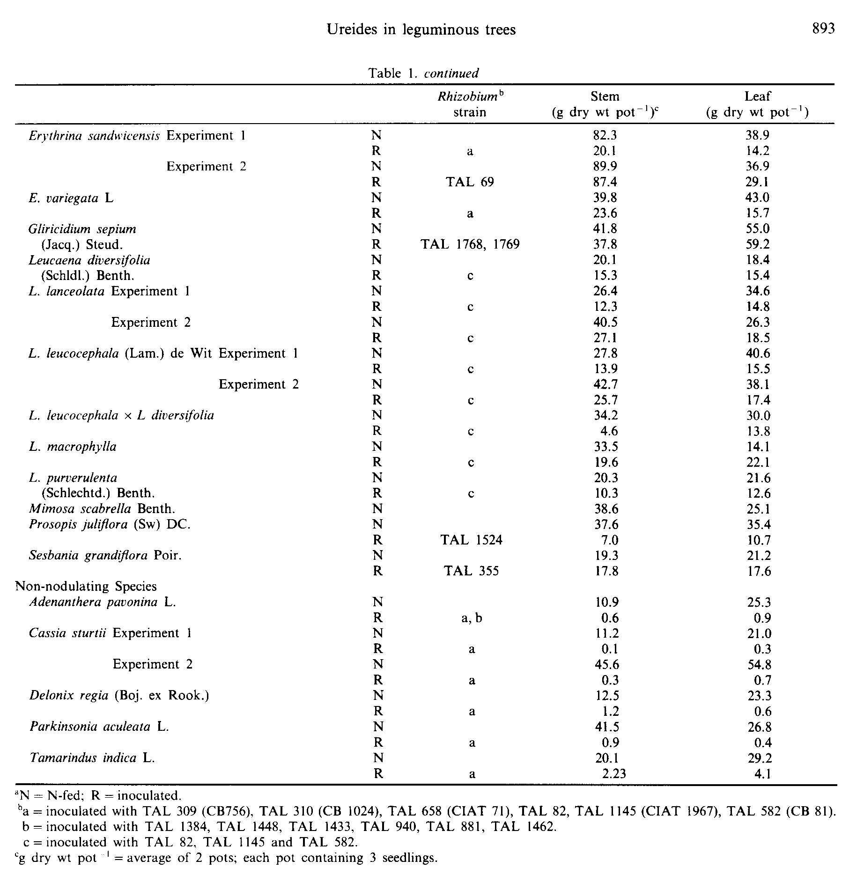
addition, although all inoculated trees of known N₂⁻fixing species formed nodules, it is possible that the rhizobia used as inoculants on some species were not highly effective at fixing N.
Xylem sap, obtained from 28 species (Table 2), contained nitrate, ureides and amino-acids. The presence of nitrates in the exudates of some plants totally dependent on N from fixation, may have been due to a slight nitrate contamination of the nutrient solution, which measured 1.2 mg NO₃ -N 1⁻'. Ureides also occurred in xylem sap of known non-N₂-fixing species, i.e. T. indica, and in samples from NH₄NO₃ fertilized as well as nodulated N₂-fixing species. The presence of ureides in xylem sap of non-nodulated soybeans has been reported (Pate et al., 1980; Yoneyama et al., 1985; Patterson and LaRue, 1983). Furthermore, McNeil and LaRue (1984) found that non-nodulated soybean could have from 9.0 to 31.8% of xylem sap N in the form of ureides, depending on the amount of nitrate supplied. Our
results confirm that the nodule is not the only site of ureide formation in legumes.
Ureides were the major N compound in the xylem sap of only two nodulated species, A. mearnsii and S. grandi flora, which 81.5 and 78.8% of the total sap N was in the form of ureides. Xylem sap from NH₄NO₃ fed non-nodulating plants of these species contained 5.4 and 47.3% ureides, respectively (Table 2). These results suggest that measuring the relative abundance of ureides in sap may not only be a useful indicator of N₂-fixing activity but also a way to quantify fixation in situ for these species. Concentrations of ureides in the xylem sap of A. arabica, Erythrina variagata and Gliricidia sepium were not greater than 20%. However, the difference between the ureide concentrations in fixing and non-fixing individuals (Table 2) of these species may be large enough to permit use of the ureide technique.
Leaf extracts on N-fed trees of all species tested contained ureides, nitrate and amino-acids (Table 3).
4
Ureide concentrations in the leaves of A. mangium, Al. lebbek, Calliandra colothyrsus and Prosopis juliora supplied with mineral N were at least twice that found in leaves of the same species dependent on N from fixation, perhaps due to the accumulation of N-rich ureides in the N sufficient, NH₄NO₃-fed plants. Ureides produced in the nodules of fixing plants were probably quickly metabolized and therefore not as likely to accumulate in the leaves of these N-insufficient plants. The relative amount of ureides in leaves of all N-fertilized, fixing-species varied from 0.7% for A. cincinnata to 18.7% for G. sepium.
Most inoculated trees lacked nitrates in the leaf extracts, but all contained ureides and amino-acids with amino-acids constituting the bulk of the N
compounds measured. Of all species tested, only leaves from G. sepium, A. auriculiformia and A. mearnsii had a relative abundance of ureides greater that 20%. These species also had large differences in the ureide levels between nodulated and N-fed plants.
Unlike leaves, stems from inoculated trees of N₂ -fixing species consistently had higher levels of ureides than stems from trees dependent on mineral N (Table 3). For nitrates, the pattern was reversed. However, the dominant N-compounds in stem tissue from both fixing and N-fertilized trees was again amino-acids. Stem extracts from inoculated trees of A. cincinnata, A. confusa, A. cowleana, A. mangium, A. mearnsii, A. nilotica, Al. falcataria and P. juliora had ureide concentrations of 20% or greater. How-
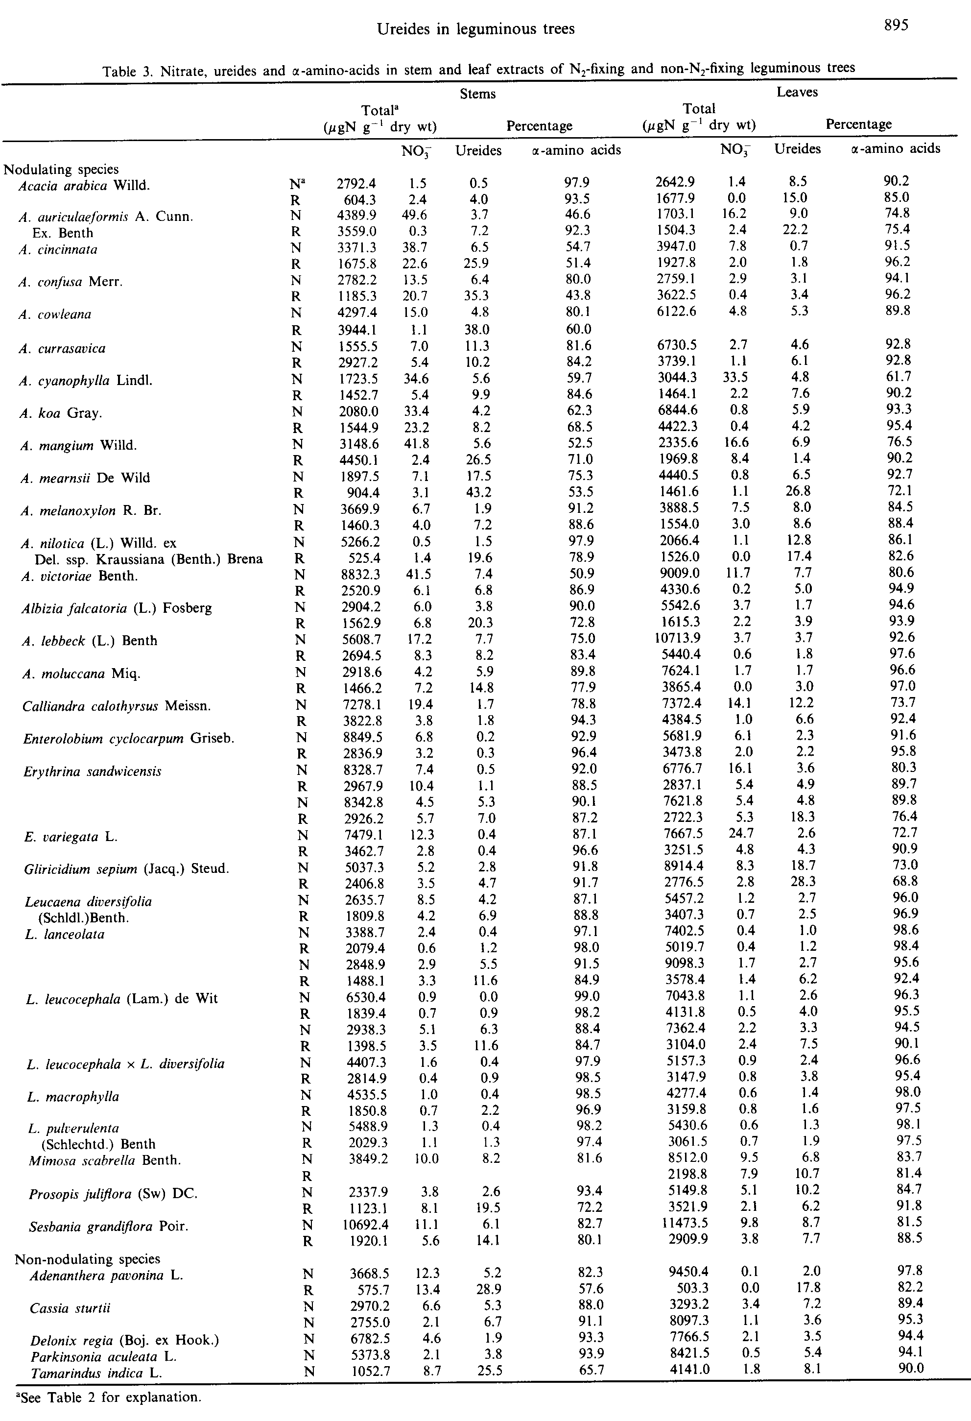
biology (N. S. Subba. Ed.). Oxford and IBH Publishing Co., New Delhi.
Halliday J. and Nakao P. (1984) Technical note on the germination of leguminous tree seeds. Pesyuisas Agropecuarias Bracilensis 19, 231-234.
Hansen A. P. and Atkins C. A. (1987a) Relationship between acetylene reduction activity, hydrogen evolution and nitrogen fixation in nodules of Acacia spp: experimental background to assaying fixation by acetylene reduction under field conditions. Journal of Experimental Botany 38, I-12.
Hansen A. P. and Pate J. S. (1987b) Evaluation of the 'SN natural abundance method and xylem sap analysis for assessing N₂ fixation of understory legumes in Jarrah (Eucalyptus margarita Dann ex sm.) forest in SW Australia. Journal of Experimental Botany 38, 1446-1458. Herridge D. F. (1982) Relative abundance of ureides and nitrate in plant tissues of soybeans as a quantitative assay of nitrogen fixation. Plant Physiology 70, 1-6.
Herridge D. F. (1984) Effects of nitrate and plant development on the abundance of nitrogenous solutes in root-bleeding and vacuum-extracted exudates of soybean. Crop Science 25, 173-179.
Keeney D. R. and Nelson D. W. (1982) Nitrogen-inorganic forms. In Methods of Soil Analysis, Second Edn (A. L. Page, R. H. Miller, D. R. Keeney, Eds), pp. 643-698. American Society of Agronomy, Madison.
Knight D. H. (1975) A phytosociological analysis of a species-rich tropical forest on Barvo-Colorado Island, Panama. Ecological Monographs 45, 259-284.
Matsumoto T., Yatazawa M. and Yamamoto Y. (1977) Distribution and change in the contents of allantoin and allatoic acid in developing nodulating and nonnodulating soybean plants. Plant and Cell Physiology 18, 353-359.
McNeil D. L. and La Rue T. A. (1984) Effect of nitrogen source on ureides in soybean. Plant Physiology 74, 227-232.
McClure P. R., Israel D. W. and Volk R. J. (1980) Evaluation of the relative ureide content of xylem sap as an indicator of N_{z} fixation of soybeans. Plant Physiology 66, 720-725.
National Academy of Science (1977) Leucaena: Promising Forage and Tree Crop. for the Tropics. National Academy of Science, Washington.
National Academy of Science (1979) Tropical Legumes: Resources for the Future. National Academy of Science, Washington.
National Academy of Science (1980) Firewood Crops: Shrub and Tree Species.for Energy Production. National Academy of Science, Washington.
Pate J. S. (1980) Transport and partitioning of nitrogenous solutes. Annual Review of Plant Physiology 31, 313-340. Pate J. S., Atkins G. A., White S. T., Rainbird R. M. and Woo K. C. (1980) Nitrogen nutrition and xylem transport of nitrogen in ureide-producing grain legumes. Plant Physiology 65, 961-965.
Patterson T. G. and LaRue T. A. (1983) N_{Z} fixation (C_{z} H_{Z}) and ureide content soybeans: environmental effects and source-sink manipulations. Crop Science 23, 819-824. Roskoski J. P. (1981) Nodulation and N_{Z} fixation by Inga jinicuil, a woody legume in coffee plantation. I. Measurements of nodule biomass and field C₂H₂ reduction rates. Plant and Soil 59, 201-206.
Roskoski J. P., Castilleja G., Frias L, Pardo E. and Vargas A. (1980) Woody tropical legumes: potential sources of forage, firewood, and soil enrichment. In Tree Crops for Energy Co-Production on Farms, pp. 135-155. National Technical Information Service, Springfield, Virginia.
Rundel P., Nilsen E. T., Sharifi M. R., Virginia R. A., Jarrell W. M., Kohl D. D. and Shearer G. B. (1982) Seasonal dynamics of nitrogen cycling for a Prosopis woodland in the Sonoran desert. Plant and Soil 64, 31-42.
ever, ureides also comprised 20% of the total N in stem extracts from T. indica and A. pavonina, non-N₂-fixing species.
The relationship between the proportion of ureides in xylem sap and in stem or leaf extracts was examined. The highest correlation was found between xylem sap and stems, r = 0.63, with the correlation between xylem sap and leaves equalling 0.51. Matsumoto et al. (1977) previously found the concentration of ureides in soybean stems was greater than that in roots, nodules, pods or seeds. Van Berkum et al. (1985) reported that the concentration of ureides in xylem sap, young stem tissues, plant tops, roots, nodules and whole soybean plants correlated well with N₂ fixation. It thus appears that leguminous trees like soybeans exhibit correlations, albeit weak ones, between the ureide contents of different plant parts.
Herridge (1984) proposed that the relationship between the relative abundance of ureides (ureideN/ureide-N + NO₃-N + amino acid-N) x 100 be used to estimate the degree of N₂ -fixing activity. In our study, the generally higher concentrations of ureides found in xylem sap vs stem or leaf tissue and the ease of obtaining and processing xylem sap samples, suggest that xylem sap is the preferable plant part to analyze.
The presence of ureides in leaves of known nonfixing species as well as in the leaves of non-nodulated fixing-species indicates that the detection of ureides in leguminous trees, per se, is not proof that the tree is fixing N₂. Since many non-legumes also produce ureides (Pate, 1980), these results are not surprising. Independent of whether exudates or extracts of stems and leaves were analyzed for the presence of ureides, the absolute amount of ureides was higher in some NH₄NO₃ fertilized than in N₂-fixing plants. This fact coupled with dominance of amino-acids in all but a few extracts and exudates, suggests that the relative abundance of ureides is not useful for estimating N₂ fixation by most of the tree species we examined. However, the data did show that the ureide technique may have utility for detecting and quantifying N₂-fixation by A. mearnsii, G. sepium and S. grandiora in situ, and suggested that further work is needed to establish definitely whether several Acacia species, Albizia falcataria and Prosopis juliflora produce ureides in amounts adequate for diagnostic purposes. Lastly, the results of our study indicate that greenhouse studies comparing ureide production by N₂-fixing and N fertilized plants of the same species are essential for establishing whether a tree species is a ureide exporter when fixing N₂.
Acknowledgements-We thank Charles Bowers for technical assistance and Susan Hiraoka for typing the manuscript. This work was supported by grants from the U.S. Agency for International Development and the McIntireStennis Program.

REFERENCES

Allen O. N. and Allen E. K. (1981) The Leguminosae. A Source Book of Characteristics, Uses, and Nodulation. University of Wisconsin Press, Madison.
Atkins C. A. (1982) Ureide metabolism and the significance of ureides in legumes. In Advances in Agricultural Micro
6
C. VAN KESSEL et al.
Shearer G. and Kohl D. H. (1986) N_{Z} fixation in field settings: estimates based on natural 'SN abundance. Australian Journal of Plant Physiology 13, 699-756. Shearer G., Kohl D. H., Virginia R. A., Bryan B. A., Skeeters J. L., Nilsen E. T., Sharifi M. R. and Rundel P. W. (1983) Estimates of N₂ -fixation from variation in the natural abundance of 'SN in Sonoran desert ecosystems. Oecologia 56, 365-373.
Van Berkum P., Sloger C., Weber D. F., Gregan P. B. and Keyser H. H. (1985) Relationship between ureide N and N_{z} fixation, aboveground N accumulation, acetylene re
duction, and nodule mass in greenhouse and field studies with Glycine max L. (Merr). Plant Physiology 77, 53-58. Yemm W. W. and Cocking E. C. (1955) The determination of amino acids with ninhydrin. Analyst 80, 209-213. Yoneyama T., Karasuyama M., Kouchi H. and Ishizuka J. (1985) Occurrence of ureide accumulation in soybean plants. Soil Science and Plant Nutrition 31, 133-140. Young E. G. and Conway C. F. (1942) On the estimation of allantoin by the Rimini-Schryver reaction. Journal of Biological Chemistry 143, 839-853.
7
Ureides in leguminous trees

8
C. VAN KESSEL et al.
0.5 mmol P as KH,P0₄, 0.5 mmol K as KHP0₄, and 80,q 1 I⁻' of micronutrient solution (Monterey Chemical Co.) which contained 1% Mo, 2.5% S, 0.35% B, 0.03% Co, 1.5% Fe, 0.45% Mn, 0.04% Mo, 0.5% Zn and 0.15% Cu. Uninoculated seedlings received 15 mmol N day⁻'in the form of NH₄NO₃ which was mixed into the N-free nutrient solution that the uninoculated seedlings received.
Initially, 29 species were established and grown for 6 months. Ten additional species were set-up during a second experiment and also grown for 6 months. Four species, Leucanea leucocephala, L. lanceolata, Erythrina sandwicensis and Cassia sturtii were set up in both experiments. A. mearnsii seedlings, solely dependent on N from fixation, were planted during the first experiment but grew so slowly that they were harvested at the end of the second experiment.
At the time of harvest, xylem exudates were collected from stems as described by Herridge (1984). Plants were then removed from the pots, checked for the presence of nodules and separated into roots, stems and leaves. After drying at 70°C to a constant weight, dry wt of leaves and stems were taken. Separate subsamples of leaves and stems were ground in a cyclone mill (< 0.45 mm) and a 0.5 g sample of the dried ground material was boiled for 1.5 min in 20 ml of distilled water. After cooling, the volume was made up to 100 ml, centrifuged for 20 min at 10,000 rev min⁻' and the supernatant passed through a Whatman No. 1 filter paper. All extracts, as well as exudates, were frozen until analyzed.
Ureides, allantoin and allantoic acid, were analyzed colorimetrically (Young and Conway, 1942); nitrates were measured by the cadmium reduction method (Keeney and Nelson, 1982); and total aminoacids were determined by the ninhydrin method (Yemm and Cocking, 1955) using asparagine as a standard.
RESULTS AND DISCUSSION
All inoculated trees of N,-fixing species had nodules at harvest but no NH₄ NO₃ fertilized trees of these same species were nodulated. Species reported to be non-N₂-fixers (Allen and Allen, 1981), i.e. C. sturtii, Delonix regia, Parkinsonia aculeata, T. indica and A. pavonina grown under N-free conditions, did not nodulate with any of the inoculant strains.
In general, the biomass of trees supplied with mineral N was considerably greater than that of most inoculated trees (Table 1). Exceptions were G. sepium, S. grandii lora and E. sandwicensis in Experiment 2, in which trees totally dependent on N from fixation, were comparable in size to plants supplied mineral N. One possible explanation for the observed growth difference between N₂-fixing and NH,N0₃ fed trees of the same species is that fertilized trees were not as N stressed as were inoculated trees before the onset of fixation. By the time nodulation commenced several weeks after planting, the N-fed trees were already visibly larger than the inoculated trees. In
Table 1. Stem and leaf biomass and inoculant strains
 |  | Rhizobium^{b}  strain | Stem  (g dry wt pot ')` | Leaf  (g dry wt pot ')
Nodulating species
Acacia arabica Willd. | Na |  | 45.7 | 29.5
 | R | a | 9.7 | 7.9
A. auriculaeformis | N |  | 9.1 | 18.7
A. Cunn. Ex. Benth | R | a, b | 0.2 | 1.9
A. cincinnata | N |  | 11.0 | 40.8
A. confusa Merr. | N |  | 7.4 | 10.9
 | R | a | 0.3 | 0.8
A. cowleana | N |  | 9.5 | 25.7
 | R | a, b | 0.6 | -
A. currasavica | N |  | 19.8 | 36.6
 | R | a | 1.5 | 5.7
A. cyanophylla Lindl. | N |  | 31.2 | 25.9
 | R | a | 7.8 | 9.4
A. koa Gray. | N |  | 7.7 | 4.6
 | R | a, b | 0.7 | 1.6
A. mangium Willd. | N |  | 11.3 | 45.5
 | R | a, b | 0.1 | 0.5
A. mearnsii De Wild | N |  | 39.0 | 54.8
 | R | a, b | 20.3 | 17.6
A. melanoxylon R. Br. | N |  | 45.5 | 44.4
 | R | a, 6 | 0.3 | 0.7
A. nilotica (L.) Willd. ex | N |  | 48.6 | 36.8
Del. ssp. Kraussiana (Benth.) | R | a | 14.8 | 11.5
A. victoriae Benth. | N |  | 0.7 | 2.4
 | R | a, TAL 72, c | 0.6 | 0.9
Albizia falcatoria (L.) Fosberg | N |  | 24.2 | 42.9
 | R | a, TAL 1300 | 0.6 | 3.3
A. lebbeck (L.) Benth. | N |  | 47.7 | 18.0
 | R | a | 0.8 | 2.7
A. moluccana Miq. | N |  | 34.0 | 57.3
 | R | a | 0.7 | 3.6
Calliandra calothyrsus Meissn. | N |  | 28.7 | 22.7
 | R | a | 7.3 | 11.7
Enterolobium cyclocarpum Griseb. | N |  | 41.9 | 32.0
 | R | a | 8.1 | 8.7

continued

